**Necessary Software**

Note: I included the versions that this software was created and tested in. It may work on newer versions but there is no guarantee.

**IDE**

<https://www.eclipse.org/downloads/packages/release/2021-03/r/eclipse-ide-java-developers>

**Java**

<https://www.oracle.com/java/technologies/javase/javase8u211-later-archive-downloads.html>

**Firefox**

firefox installed VERSION: 89.0.1 (32-bit)

<https://www.mozilla.org/en-US/firefox/89.0.1/releasenotes/>

**Git bash**

<https://git-scm.com/downloads>

**Cisco Anytime connect VPN**

**First time Set up**

**Open Git bash**



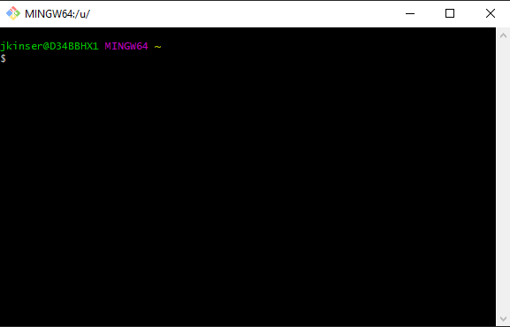

**Navigate to new directory**

Important commands

cd /path: change directories

pwd: see what directory you are currently in

ls: see items in current directory

mkdir directoryName: make a new folder in your current directory

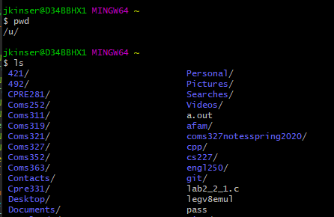

I used ls and see my Documents folder so I will enter that folder



I will know make a new directory for the project

mkdir new_project

I will now change into that directory

cd new_project

**Cloning Project**

Once in your new directory, head over to <https://github.com/Jacob-Kinser/MysoftProject>

If you are not a collaborator on this project, email [jacobmkinser@gmail.com](mailto:jacobmkinser@gmail.com) with your github account name and I will add you as a collaborator

Once here. Click on the green code button and copy the HTTPS link using the copy button

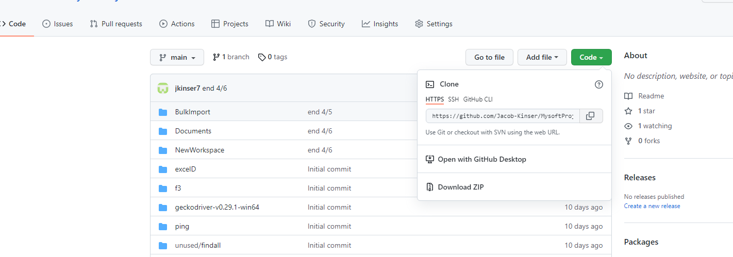

Head back over to git bash and enter the following command

git clone https_link_you_just_copied

The project will exist in your current directory

Enter ls to see your new project and use the cd command to enter into the folder

**Opening Eclipse**

Open your recently installed Eclipse and for the workspace, naviagate to your project folder->NewWorkspace

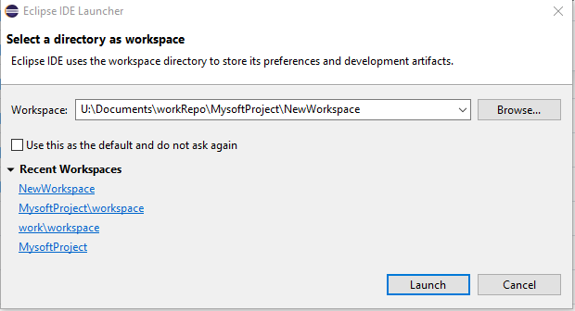

Then click launch

**Import the project**

Sometimes eclipse may not recognize your project the first time you enter eclipse.

If your package explorer looks like the image below, skip this step

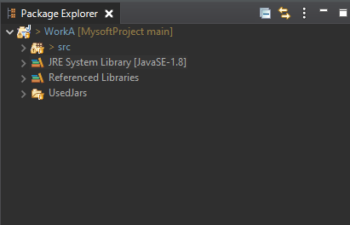

If not Click on File in the top left corner and click import

***

**Including Jar files**

This project uses different tools that allow it to interact with web pages, read excel files, etc. You will need to import the jars during your first time set up